

IBM ASSIGNMENT 1

AYMAN ABDUL KADER

960519205005

# IBM COGNOS ANALYTICS WITH WATSON

* R&D SPEND BY STATECOLORED BY ADMINISTRATION
* MARKETING SPEND AND R&D SPEND STATE FOR STATE COLORED BY ADMINISTRATION
* STATE FOR R&D SPEND HIERARCHY
* ADMINISTRATION BY STATE
* SUMMARY
* LINK TO OPEN MY DATA VISUALIZTION IN THE COGNOS ANALYTICS

**R&D SPEND BY STATECOLORED BY ADMINISTRATION**

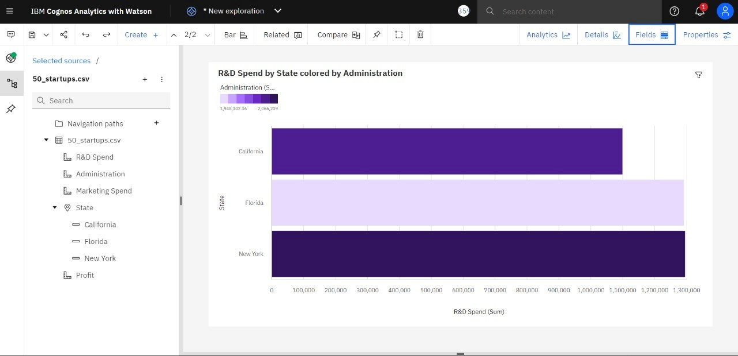

**MARKETING SPEND AND R&D SPEND STATE FOR STATE COLORED BY ADMINISTRATION**

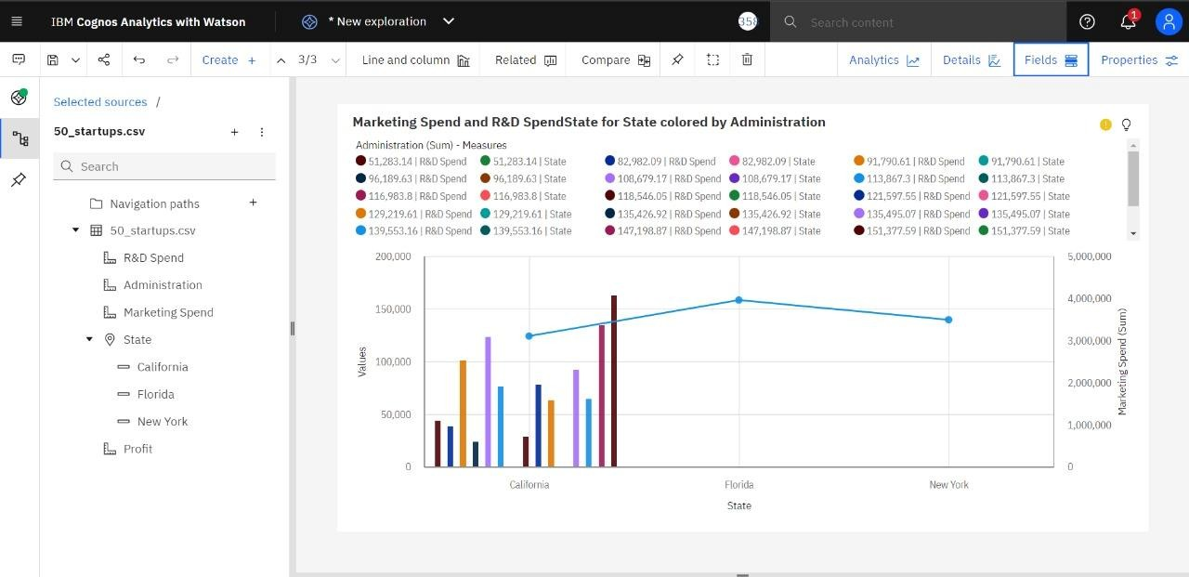

**STATE FOR R&D SPEND HIERARCHY**

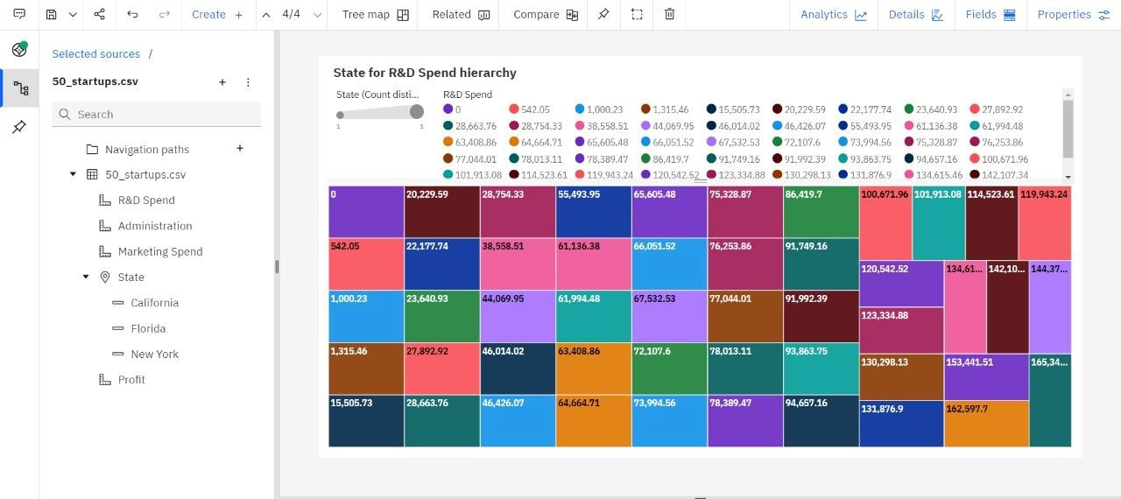

**ADMINISTRATION BY STATE**

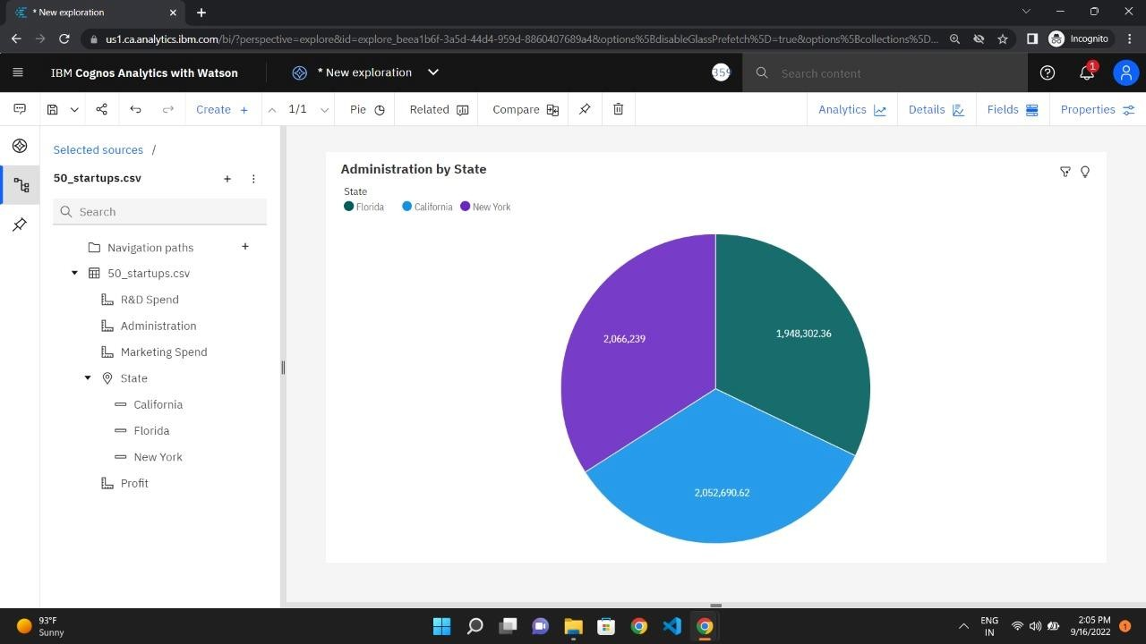

**SUMMARY**

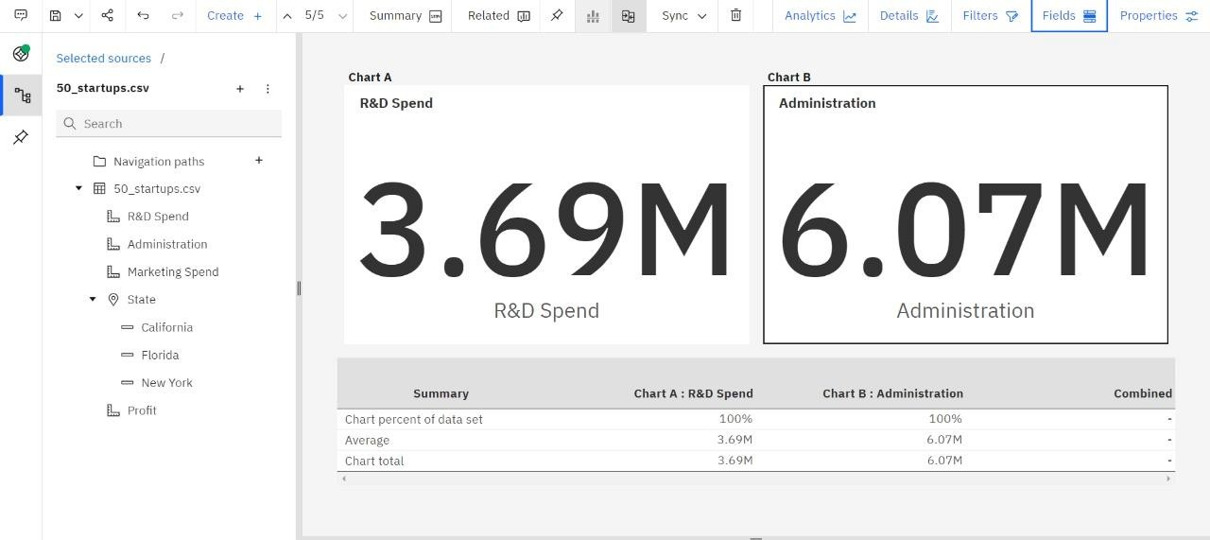

# LINK TO OPEN MY DATA VISUALIZTION IN THE COGNOS ANALYTICS

https://us1.ca.analytics.ibm.com/bi/?perspective=explore&pathRef=.my_fol ders%2Fdata%2Bmodule%2F50%2Bstartups&subView=model0000018345 b9fac8_00000004